15
Survival analysis: an introduction

Kaplan-Meier survival analyses in R

To explain how to generate a survival curve in R we will use the data from Table 15.1. In order to conduct a survival analysis in R, you should set out you data in an Excel file in the same way that we have (Screenshot 1):

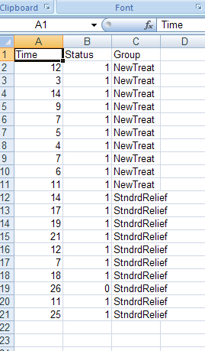
Screenshot 1

You should notice from Screenshot 1 that we have three variables. One contains the time to the event (or end of study as in the case of row number 19 in the data file). The second column contains the status of the individual at that particular time point. In here, we either put a ‘1’ or ‘0’, ‘1’ meaning that they experienced the event (had a Migraine in this example) or ‘0’ meaning that they are a censored data point (they were either lost to the study or did not experience the event within the time frame of the study). The third column simply indicates which condition each participant was in.

You should load this data into R and then you need to use the survfit() command to run the Kaplan-Meier survival analysis e.g.

> fit <- survfit(Surv(Time, Status) ~ Group, data = Pain)
Here we have the Time variable first in the brackets and the status variable comes second. After the tilde (~) we place the grouping variable. Finally, if we have not used the attach() command prior to running the analysis, we can indicate which data frame to use by using the data = option. We save the outcome of this analysis into the variable name ‘fit’ in our example. Once we have done this we need to tell R to plot the survival curve by reference to the information stored in ‘fit’. We do this

>plot(fit, lty=2:3)

The lty= part of this specifies the types of lines that are generated on the graph. Using 2:3 gives two different types of dotted lines.

When you enter this command you will be presented with the survival curves presented in Figure 1:

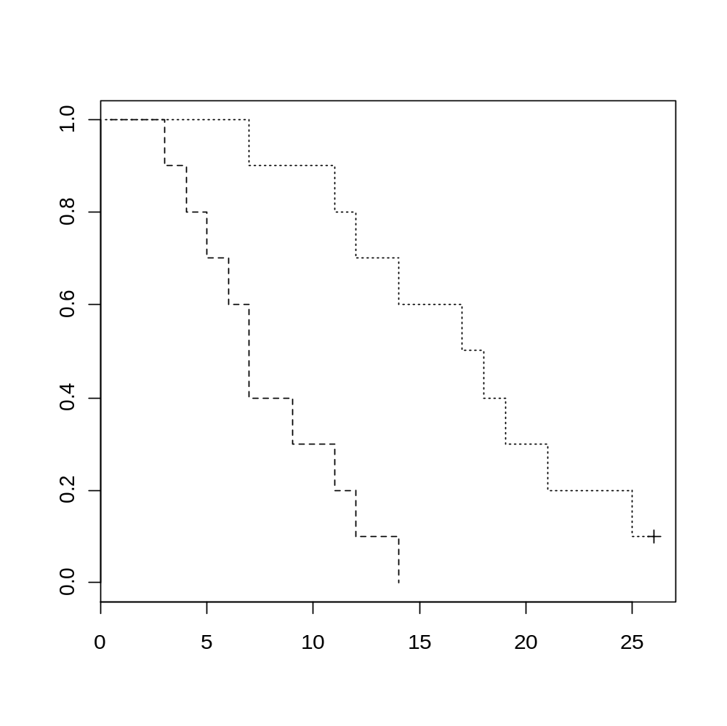
Figure 1

Mantel-Cox (log rank) test using R
The best way to generate a log rank in R is to use the coxph() command. This runs a Cox proportional hazards regression and part of the output from this contains the log rank test. To run the test we use the data that we loaded up for demonstration of the generating survival curves. Remember, this data frame was called ‘Pain’. The commands that you need to run are:
>CoxReg <-coxph(Time, Status~Group, Pain)
In this command, we have stored the output of the analysis in the variable ‘CoxReg’. We then need to present the summary of this output using the summary() command e.g.
>summary(CoxReg)

When you run these two commands you will be presented with the output shown in Screenshot 1:

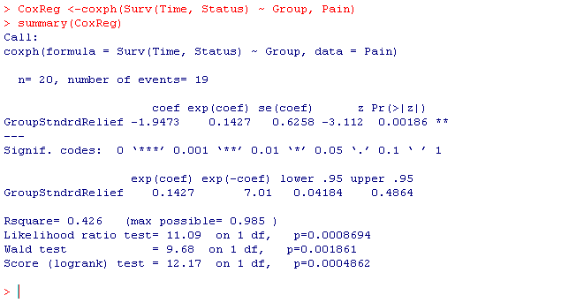Screenshot 1
The part of the printout that we are interested in is at the very bottom of the output and is called the ‘Score (logrank) test. We have a log rank value of 12.17, with 1 df and an associated p-value of P< .001.

Hazard functions in R
In order to generate the Hazard curve in R you follow the procedure above for generating survival curves. You then simply add an extra argument in to the brackets following the plot() command. You use the fun=”cumhaz” argument to generate the cumulative hazard curve rather than the survival curve. The command will look like this:

>plot(fit, lty=2:3, fun=”cumhaz”)

When you run this command after running the survfit() command you will get the hazard curves presented in Figure 2.

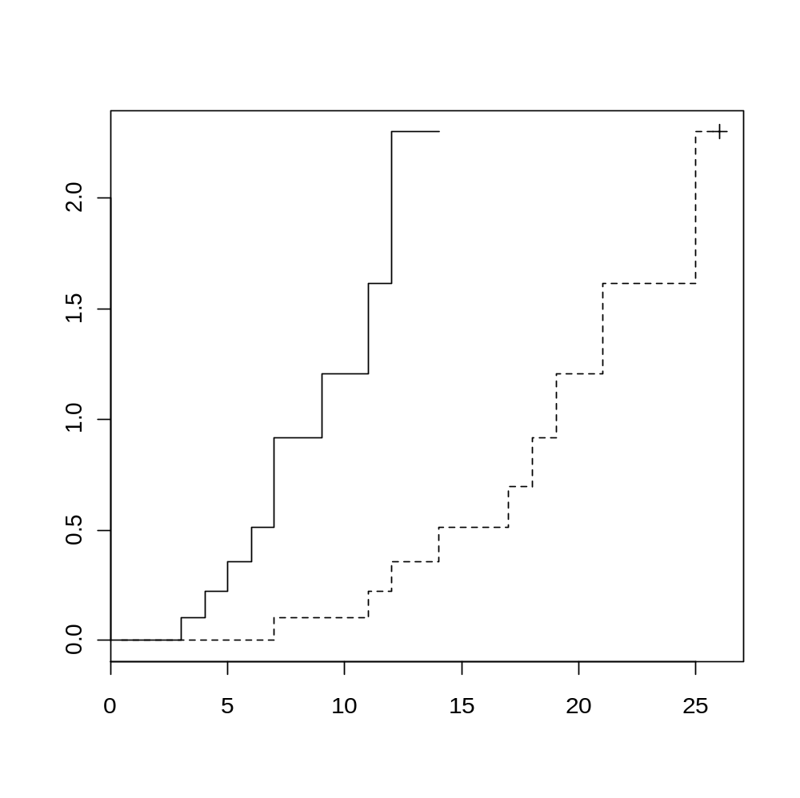
Figure 2

